**EXERCISE: 11**

**DATE: 21.11.2020**

**AIM:**

To write a Python program to find the greatest common divisor (GCD) of two integers using recursion.

**PROGRAM:**

def gcd(a,b):

if(b==0):

return a

else:

return gcd(b,a%b)

a = int(input("Enter first number: "))

b = int(input("Enter second number: "))

GCD = gcd(a,b)

print("GCD is: ")

print(GCD)

**LINK:**

**http://103.53.53.18/mod/vpl/forms/submissionview.php?id=326&userid=1747**

**OUTPUT:**

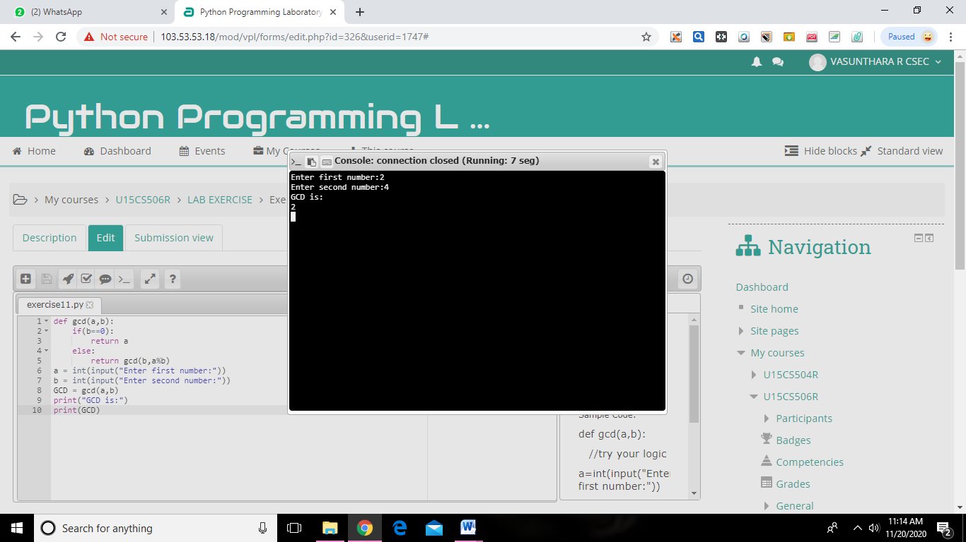

**RESULT:**

The greatest common divisor (GCD) of two integers using recursion is successfully obtained.